MEMBER WORKSHOP 2019
District Six
Sons of Norway

Mission of Sons of Norway
The mission of Sons of Norway is to promote and to preserve the heritage and culture of Norway; to celebrate our relationship with other Nordic countries; and to provide quality insurance and financial products.
International Goals
Attain 300 new insurance members
Achieve $4.8 million in total life insurance premiums
Accomplish $16.5 million in total annuity premiums
Acquire 3,300 new members
Arrive at $200,000 Foundation funds raised

What IS in it for ME? And for YOU and for OUR LODGES; how do we find out about benefits?
1. For what reason(s) do people join Sons of Norway? For what reason did you join?

2. What is the reason that Sons of Norway was founded?
2a. Sons of Norway was organized as a fraternal benefit society by 18 Norwegian immigrants in Minneapolis, Minnesota, on Jan 16, 1895. The purposes and goals of the Founding Fathers were to protect members of Sons of Norway and their families from the financial hardships experienced during times of sickness or death in the family. Over time, the mission of Sons of Norway was expanded to include the preservation of Norwegian heritage and culture in our Society. We have grown since our beginning and are now the largest Norwegian organization outside Norway. This type of organization is now called ‘A Fraternal Benefit Society’, For the IRS it is classified as a non-profit 501(c) (8).
2b. other ‘fraternal benefit’ societies include: Eagles, Odd Fellows, Vasa (Swedish Lodge) Danish Brotherhood, Finnish, Italian, maybe Labor unions, and the Grand Daddy of all, the Masons. The wording, the structure, the password are based on the Masons.

3. What is the Mission Statement?
The mission of Sons of Norway is to promote and to preserve the heritage and culture of Norway, to celebrate our relationship with other Nordic Countries, and provide quality insurance and financial products to our members.

4. How do you pursue these interests? What is the advantage to Sons of Norway members?
People share in their homes, with the extended family and with friends who share ethnic interests such as holidays and foods, traditions at weddings, children’s traditions of toys and games, songs and dance. Some join Sons of Norway to learn about culture and traditions in depth and most people will go to the public library, encyclopedias or to the web to look up various subjects. Some members of Sons of Norway have access to their lodge library and to programs presented by the lodge monthly.

5. How does a person and/or a lodge promote and preserve our heritage and culture?
Today, Sons of Norway members promote Norwegian and Scandinavian traditions and fellowship through the cultural and social opportunities offered in local lodge and district lodge activities. These ‘fraternal’ activities include language camps and classes, scholarships, handicrafts, cooking and heritage classes, heritage programs, sports programs, travel opportunities, Viking Magazine, and outreach programs sponsored by the Sons of Norway Foundation. Families continue the traditions passed down as well as integrating the skills learned in Sons of Norway classes.

6. How does Sons of Norway continue to care for its members in hardships of sickness and death? How does your Lodge show care? We offer financial protection through our Sons of Norway field staff representatives (Financial Benefits Counselors—FBCs) to Sons of Norway members and their families against the hardships of sickness and death with a variety of quality financial programs. The Local Lodges have individual ways of caring . . . cards, plants, visits, funding scholarships, attending funerals dressed in their Norwegian sweaters and singing as a group . . . we need to be sure we are personal in our caring.

Membership Charts and Dues Information
This chart lists the membership dues starting Jan. 1, 2018, for all membership classes. The total dues amount is shown for members in United States lodges.

United States
 |  |  |  | Total Dues
 | Intl. | Dist. | Local | Annual | Mthly
Individual
Regular | $32.00 | $14.00 | $14.00 | $60.00 | $5.00
Golden | $16.00 | $14.00 | $12.00 | $42.00 | $3.50
Lifetime | $0.00 | $0.00 | $0.00 | $0.00 | $0.00
Family
Regular | $42.00 | $25.00 | $28.00 | $95.00 | $8.00
Both Golden | $21.00 | $25.00 | $14.00 | $60.00 | $5.00
One Golden/One Regular | $32.00 | $25.00 | $21.00 | $78.00 | $6.50
One Golden/One Lifetime | $16.00 | $14.00 | $12.00 | $42.00 | $3.50
One Regular/One Lifetime | $32.00 | $14.00 | $14.00 | $60.00 | $5.00
Both Lifetime | $0.00 | $0.00 | $0.00 | $0.00 | $0.00
Central Lodge | Intl. | Dist. | Local | Annual | Mthly
Individual Without Insurance | $32.00 | $28.00* | $0.00 | $60.00 | $5.00
Individual With Insurance | $10.00 | $14.00 | $0.00 | $24.00 | $2.00
Family Without Insurance | $42.00 | $53.00* | $0.00 | $95.00 | $8.00
Family With Insurance | $11.00 | $25.00 | $0.00 | $36.00 | $3.00

So, you’ve joined Sons of Norway -- here’s an overview of the organization.
Let’s talk about the structure of Sons of Norway
What are three levels in the Sons of Norway and most fraternal organizations? Local - District - International.

Each of us is an individual member of the local organization which is called a LODGE’ - meaning, a fraternal benefit organization.

What is a LOCAL Level? A local lodge has its own bylaws fitting into the larger organization’s structure. While Sons of Norway has a Mission Statement, a local lodge can write its own local mission statement and some lodges have. A lodge is a ‘subsidiary’ of the Sons of Norway and is independent financially with its own set of officers. The lodge determines its own calendar and programs within the purposes and bylaws of the District and International Lodges. Individuals pay dues to support the International and District lodges.

What questions have you been asked about who can join a LOCAL LODGE? Reasons for NOT joining or NOT feeling eligible?
ANYONE who is interested in Norway and the Nordic countries may join Sons of Norway. There is no need to be Norwegian, married to a Norwegian or have Norwegian ‘blood’. Since “1945ish”, women are included as members and at the same time English began to be used in conducting meetings.

How do people join Sons of Norway? Fill out the Membership Form and pay the dues! Payment of dues by check or on-line, going to the sofn.com website with a credit card, ensures that an interested party can become a member of this great organization. People join a Local Lodge to participate with others in mutual interests and to be eligible to purchase any financial products of Sons of Norway, as well as being able to get discounted tours and hotel rates.

Local Lodge Membership, Recruitment and Retention:
- Programming, Programming, Programming. Stress cultural elements in your lodge programs and
themes at socials. Include food offerings. Go beyond lutefisk!!! Use your Norwegian born members
to offer new ideas for food and program ideas from current Norway as well as the past.
- Marketing/publicity-- use a newspaper ad, free advertising in local papers, flyers out in the community,
radio spots, etc. You can obtain past Viking magazines from Headquarters.
- Network in the community at a chamber event, a heritage day and with other lodges.
- Focus on the mission statement of Sons of Norway
- Personally ask someone to join. Have your elevator speech ready to spread the word.
- Provide “give aways” that have the Sons of Norway info on it. Leave Viking magazines with a sticker
on the front with your contact information in Dr. Offices. You can obtain past Vikings from Home Office.
- Do a membership recruitment event. Talk to your FBC about this. This event can be funded by the Headquarters for up to $400.00

What is the District Lodge?
District Six is comprised of 49 lodges from the states of Arizona, California, Colorado, Nevada and Utah. In addition New Mexico and Hawaii are part of the District but have not lodges. Also there is a Central Lodge which includes insurance members and members who have not identified a lodge. The District acts as a resource to the local lodges and communicates information from the International Lodge. All member of the District Board are insurance owners.

- The District Lodge officers are President, Vice President, Secretary, Treasurer and a Public Relations Officer. In addition there is a Cultural Director and 7 Board Directors that represent the 7 different Zones of the lodges.

President | Luella Grangaard | president@sofn6.org
Vice President | Bruce Fihe | vicepresident@sofn6.org
Secretary | Nancy Madson | secretary@sofn6.org
Treasurer | Bob Sather | treasurer@sofn6.org
Public Relations Officer | Kaye Wergedal | pro@sofn6.org
Cultural Director | Judy Immel | culturaldirector@sofn6.org

- What is a ZONE DIRECTOR? Each Zone has a representative (Zone Director) on the District Board who acts as a liaison between the and is a resource to the local lodge officers. While this Zone Director acts as an advisor, he/she has no direct authority to the lodges of his/her zone. The Zone Director is elected by the delegates from that zone at the biennial District Lodge Meeting. The Zone Director has no term limitations and is directed by the Vice President of the District in his/her work with lodges.
Zone 1--Adrienne Lincoln Zone 2--Lotte Sather Zone 3—Karen Aaker
Zone 5—Troann Loy Zone 6—Ronna Clymens Zone 7—Benny Jo Hinchey
Zone 8—Bev Moe

District Six—Mission
The mission of District Six is to support Sons of Norway through communication, resources and opportunities.

Goal District Six
Include a Financial product article written by a District Six FBC in each district newsletter this biennium
Goal District Six will acquire 300 new members by 2020.
Projects:
- 12 Trollfjell Folkehøgskule Students and 20 Camp Trollfjell campers at least by 2019.
- Communication team will build District member e-mail distribution list January 2019—completed October 2019
- All lodge editors will use the Lodge Editor Distribution list by 2020.
- The Culture Director will update culture resource list by 2020
- VP and Zone Directors will develop a plan for Zone Directors to communication intra zone activities 2020
- Leadership will promote convention to obtain 160 delegates for the 2020 convention
- President and Culture chair will develop a culture grant program for District Six lodges utilizing fraternal funds by 2020.

Goal District Six
- By 2020, Treasurer will move $20,000 into Scholarship monies held with the Sons of Norway Foundation by 2020 to achieve a self-sustaining fund.
Project:
- Treasurer to write an article for the District Six newsletters to promote our District Scholarship/Foundation Fund.

What is the International Lodge?
The International Lodge carries on the business of the organization. The officers are elected by delegates from each District at the biennial International Convention. The International Lodge hires the CEO who runs the business of Sons of Norway.

International and District Conventions are held every two years (biennially) in the same even numbered year. The District will hold its convention in Mesa, AZ June 18-21, 2020, to elect its International Delegates. At the District Convention, delegates will elect new District Officers from the delegates sent by local lodges. Likewise, International Officers will be elected from the delegates sent by the eight Districts to the International Convention. The 2020 International Convention will be held in Hamar, Norway August 16-23, 2020.

The term of office for District and for International officers is two years, except the International Directors who are elected once for one four-year term. Other Officers may be re-elected one time, serving a total of four years.

As you are familiar with the District’s Zone Directors, the International Board has a similar liaison officer. The International Director attends International Board Meetings and sits in on the District Board Meetings as the representative and communicator between the District and International Lodge. The International Director has voice on the District Six Board of Directors.

The current International Officers are:
President: Ron Stubbing District 2-- Canada
Vice President: Mark Ageter District 2
Secretary: Marci Larsen District 3
Treasurer: Elaine Nelson District 4
District Six International Director: Mary Beth Ingvoldstad
CEO: Eivind Heidberg
Fraternal Director: Linda Pederson
Foundation Director: Corrie Maki Knudson

Sons of Norway has three distinctive services, which is often referred to as the 3 legged stool: the Fraternal, Foundation and Financial.

Fraternal
1-800-945-8851
- Membership
- Viking Magazine
- Cultural Skills Programs, recipe book, language lessons
- Sports Medals Programs
- Member Discounts
- Lodge Governance—Lodge supplies, Newsletter services

CULTURE SKILLS PROGRAMS, RECIPE BOOK, LANGUAGE LESSONS, MAPS
There are Culture Skills Programs that guide you through learning. Each has three levels to complete. The units include: Cooking, Literature, Music, Rosemaling, Carving, Weaving, Hardanger Knitting and more. These programs could be used for lodge programs.
Idea Banks and Mini Presentations –provide ideas for lodge programming
Family Matters Pages—have activities for youth

SPORTS MEDAL PROGRAM
Sons of Norway’s Sports & Fitness Medal Program brings a bit of Norwegian tradition to its members by encouraging everyone to participate in activities that will improve their health and well-being in ways that suit each individual’s physical capabilities. The sports included in the Sons of Norway Sports Medal Program include general fitness, skiing, swimming, biking, and walking.
The Sports & Fitness Program is an organized program. Each sport pin has 4 levels of achievement: Bronze, Silver, Gold, and Enamel. Members must work through the series in sequence, beginning with the Bronze pin. Members must complete the requirements for each level within 365 days.
NOTE: If the member completes the requirements in a shorter period, he/she can immediately begin working on the requirements for the next level in the sequence. The member may want to become more fit, continuing until the member has achieved gold and then the enamel level.

MEMBER DISCOUNTS
- PerkSpot
By visiting Sons of Norway’s exclusive PerkSpot portal you can start saving today on products and services, like travel, clothing, food, entertainment and electronics. But that’s not all! Every month new discounts are added to enhance the benefit and, once you create your account, the discounts you see will be tailored to the area in which you live!
- Sons of Norway Visa Card
Enjoy exclusive benefits with a Sons of Norway Visa card. With the Visa Signature card you'll enjoy benefits including points with every eligible net purchase, ability to redeem points for travel, merchandise, cash back and more, and convenient travel benefits.
- Films of Norway
Films of Norway offers Norwegian movies and TV series via an internet streaming service for a monthly subscription rate. Sons of Norway members in the United States qualify for 25% off the regular monthly subscription rate.
- Avis and Budget Car Rental
Members receive a 30% discount at participating locations worldwide.
- Best Western Hotel
Members receive a discount of up to 10% at any of Best Western's 3,400 hotels in the United States, Canada, and select properties in Scandinavia.
- Borton Overseas
Members enjoy a 5% Sons of Norway member discount when booking a qualifying inclusive tour package.
- Carlson Hotels
Members qualify for 5% off the regular rate at Radisson Blu, Radisson®, Country Inns & Suites By CarlsonSM, Park Inn by Radisson, and Park Plaza® hotels.
- Icelandair
Members receive a 10% discount on any published Icelandair airfare when tickets are booked through select travel agents.

Foundation 1-800-945-8851
The Sons of Norway Foundation is dedicated to funding activities that preserve and promote Norwegian heritage, positively affect members, and make Sons of Norway communities a more vibrant place to live, be it through a student's scholarship for study, a cultural exchange experience, or assisting lodges to provide quality programs and community events – the Sons of Norway Foundation is true to its mission.
Established in 1966, our focus and offerings have grown to include several categories of scholarships and five categories of grants. Our passion is focused on the following areas:
- Creating opportunities for higher education as a means for success.
- Showcasing our unique Norwegian heritage to wider audiences.
- Exploring cross-cultural exchanges.
- Providing humanitarian support to Sons of Norway members who are victims of natural disasters.
The Foundation has awarded $1,375,000 in scholarships, $390,000 in grants and more than $500,000 in humanitarian aid. Take a closer look at our efforts, the results, and opportunities to get involved.
Scholarships: The Sons of Norway Foundation awards approximately 25 scholarships to promising students each year. These programs promote cultural exchange, and support higher education to help students follow their dreams.

King Olav V Norwegian-American Heritage Scholarship

Oslo International Summer School Scholarship

Helen Tronvold Norwegian Folk High School Scholarship

Helen Tronvold Adult Learner Scholarship

Lund Fund Scholarship

Douglas Warne – Rolf & Wenche Eng Scholarship

Myrtle Beinhauer Fund
- Nancy Lorraine Jensen Memorial Scholarship Fund
- Orel and Marie Winjum Memorial Scholarship
- Bernt Anker Scholarship (2020)

Grants: these are grants that may be used for your lodge or your community

Community Partnership Grant

Helping Hands to Children Grant

Lodge Culture and Heritage Grant

Lodge Vitality Grant

Helping Hands to Members

Ways to donate

Give directly

Klubb – join the Klubb as a recurring donor

Legacy gifts—which include gifts through wills, life insurance, charitable trust, appreciated stock, and designated funds.

Fundraising opportunities
Financial 1-800-945-8851

Protecting your family, your legacy, your lodge and your community.
One thing that makes Sons of Norway unique is that purchasing financial products not only helps our members protect their family and their legacy, it also can help support their lodge and the surrounding community. That's why we're committed to providing the services and products you need, for exactly the right times in life. As a financial services organization, this has been part of our mission for more than a century. Explore the ways we help secure futures through the sound financial products and services offered by Sons of Norway.
- Advisor newsletter
- Annuity Products
- Insurance Products
- Free Financial Assessments
- Financial Benefit Counselors (FBCs)

A Flexible Premium Deferred Annuity (FPDA) helps you accumulate money for retirement and other financial needs on a tax-deferred basis. It allows you to set your own premium and make additional payments at any time. And since there are no sales charges, all of your money earns tax-deferred interest from the day it's received until the day it is withdrawn.*
By investing primarily in high-quality corporate and U.S. Government bonds and notes, Sons of Norway can offer this income product that guarantees you'll always get back 100 percent of your principal and never receive less than 1 percent interest.
A Single Premium Deferred Annuity (SPDA) helps you accumulate money for retirement and other financial needs on a tax-deferred basis. It requires a one-time minimum premium deposit of $10,000 and there are no sales charges; meaning 100 percent of your money is earning tax-deferred interest from the day it is received until the day it is withdrawn.*
By investing primarily in high-quality corporate and U.S. Government bonds and notes, Sons of Norway can offer this income product that will never receive less than 1 percent interest.
A Single Premium Immediate Annuity (SPIA) provides a fixed monthly payment in the future. You can choose these payments to cover a fixed amount of time or for as long as you live. This product is designed to handle both new premiums and as a payout of the cash value of your current Sons of Norway product.

Financial Benefits Counselors (FBC’s)
Are individually contracted Financial Representatives. Check the Sons of Norway Website to find a Financial Benefits Counselor near you.

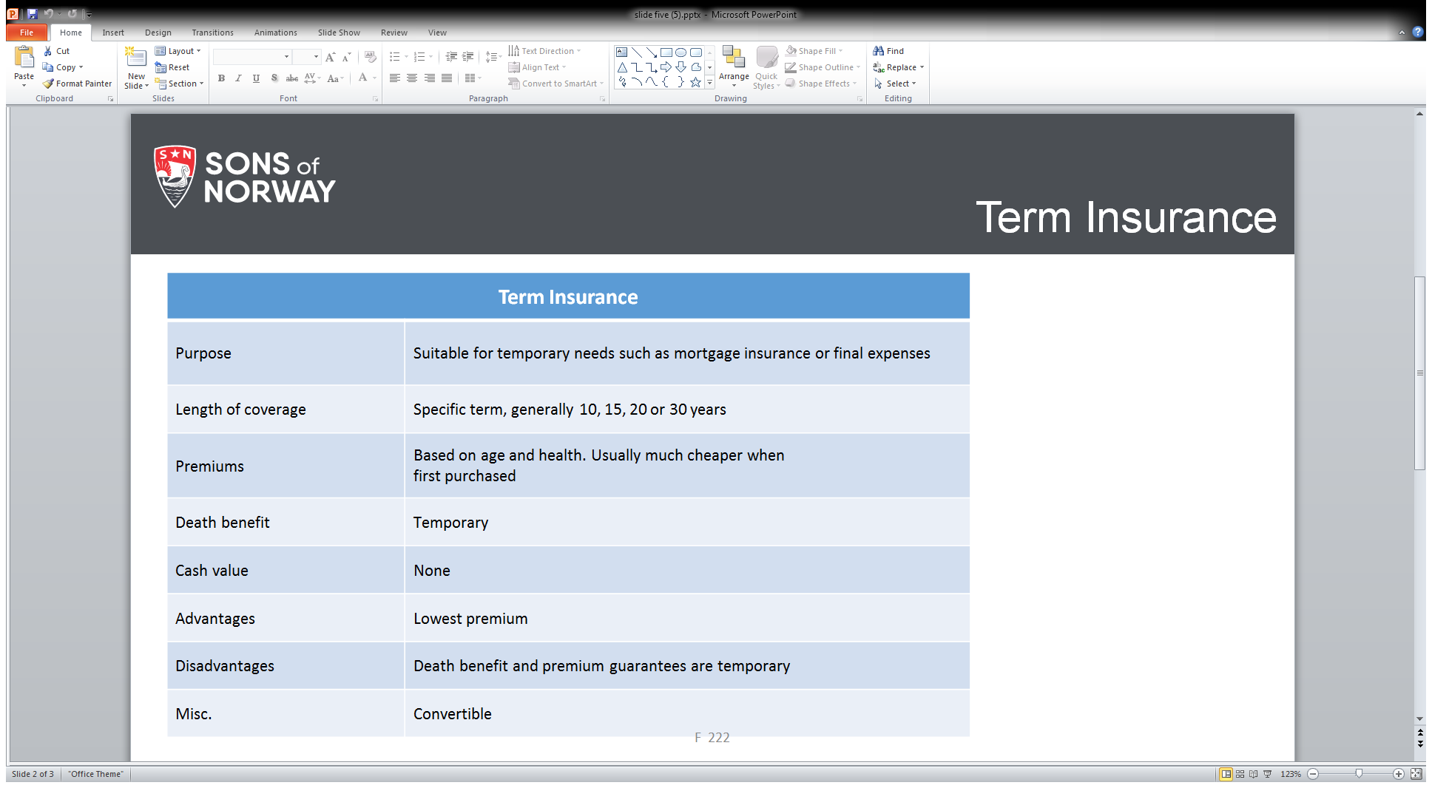
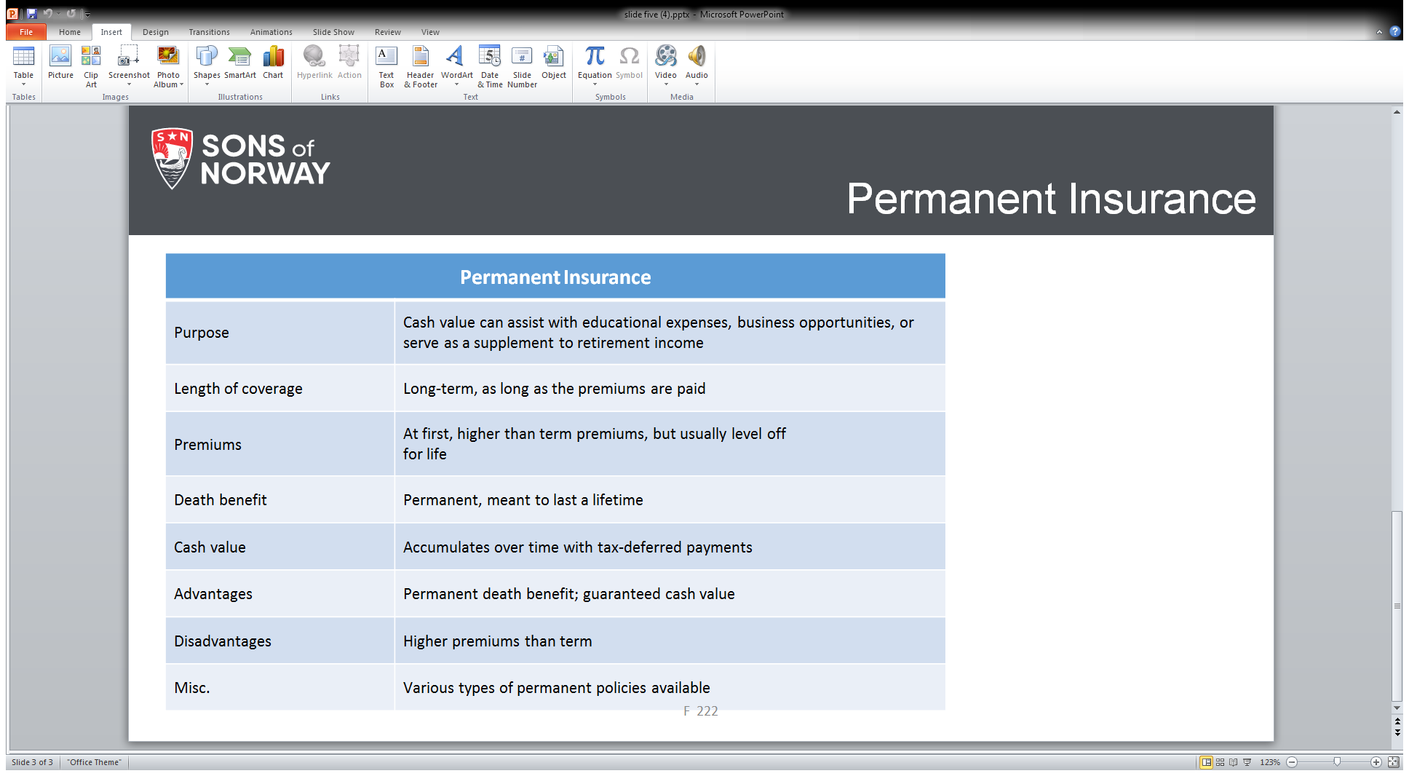

Sons of Norway Website—Resources
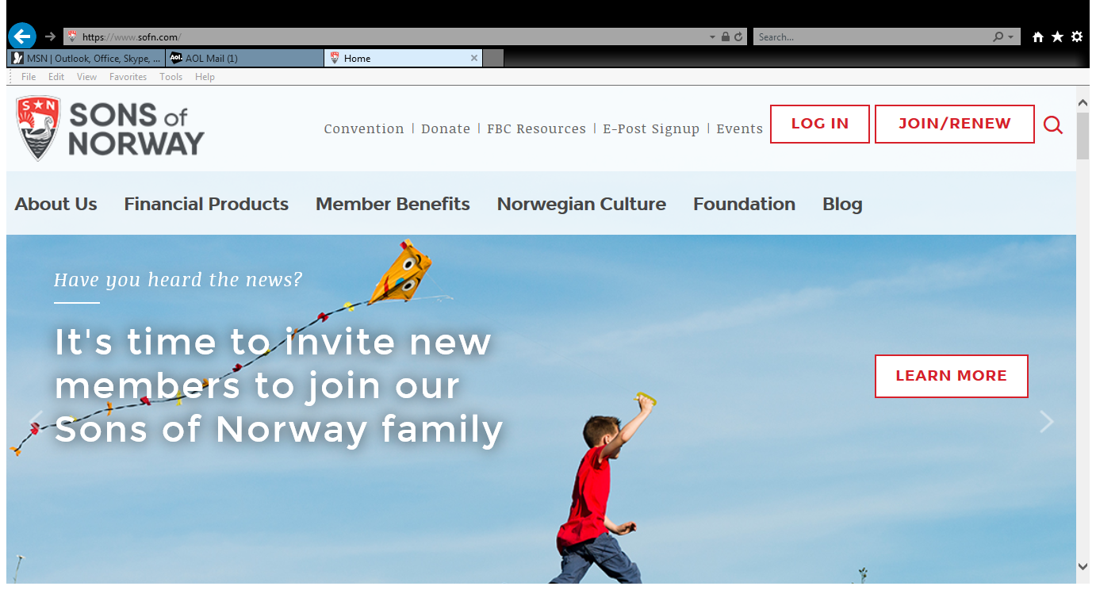

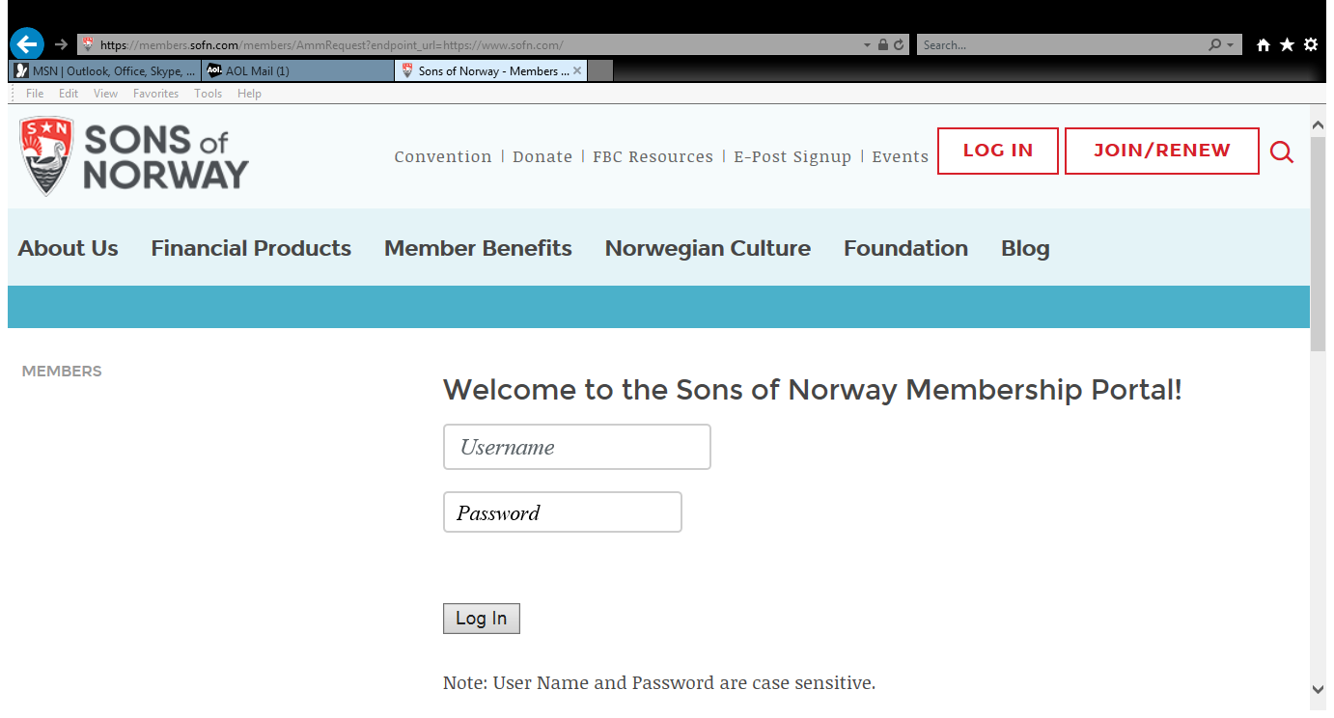

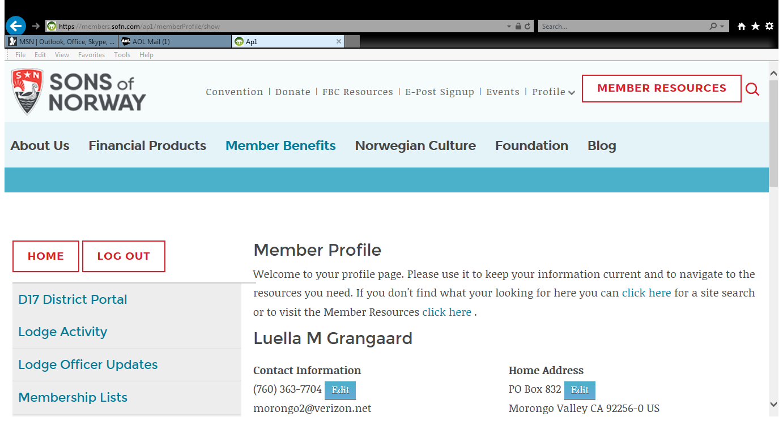

Click on Member Resources

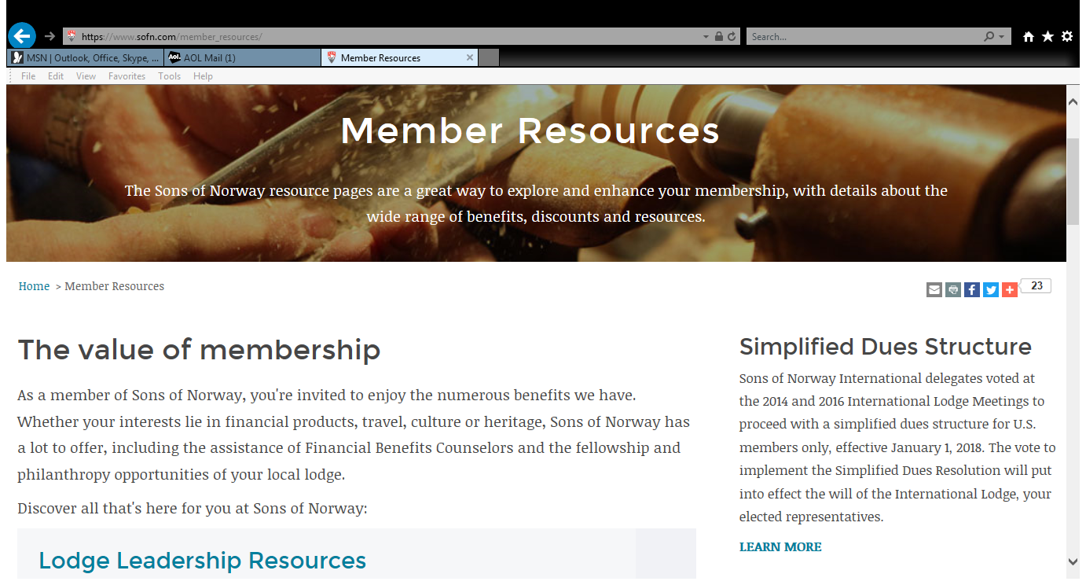

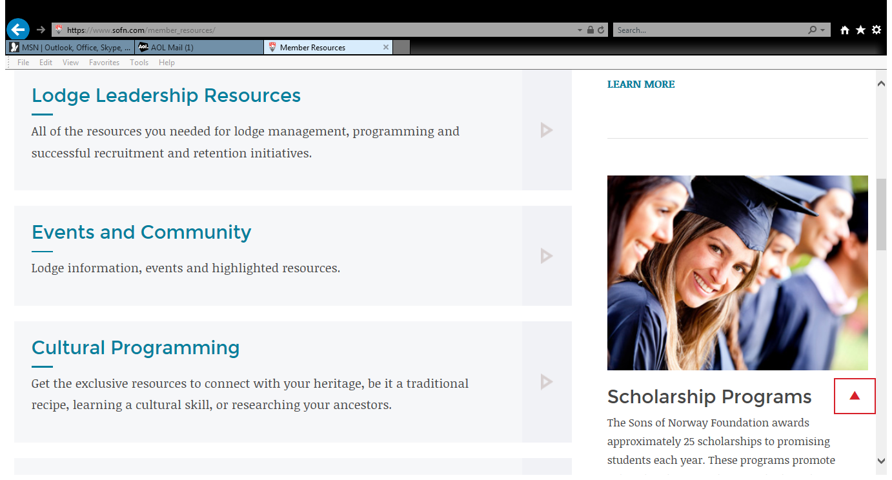
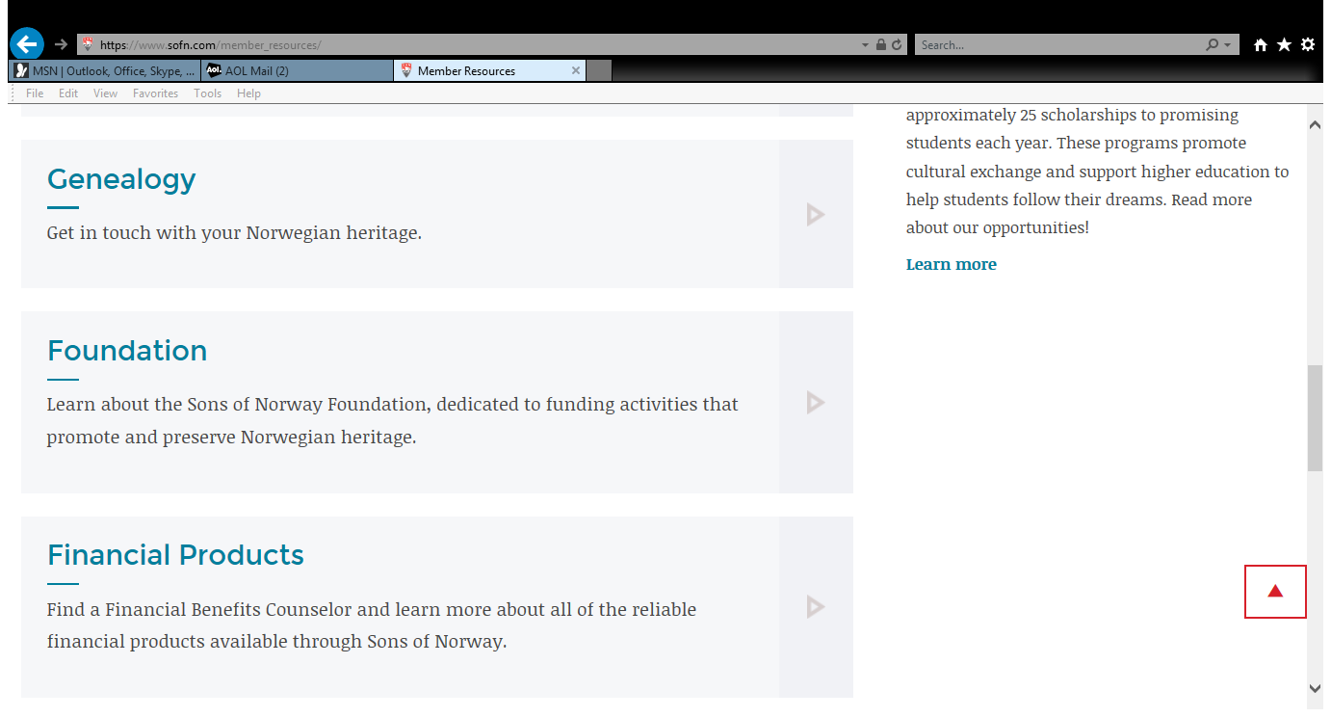
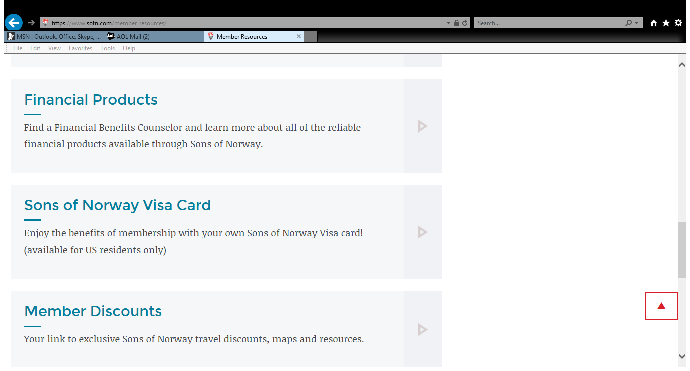

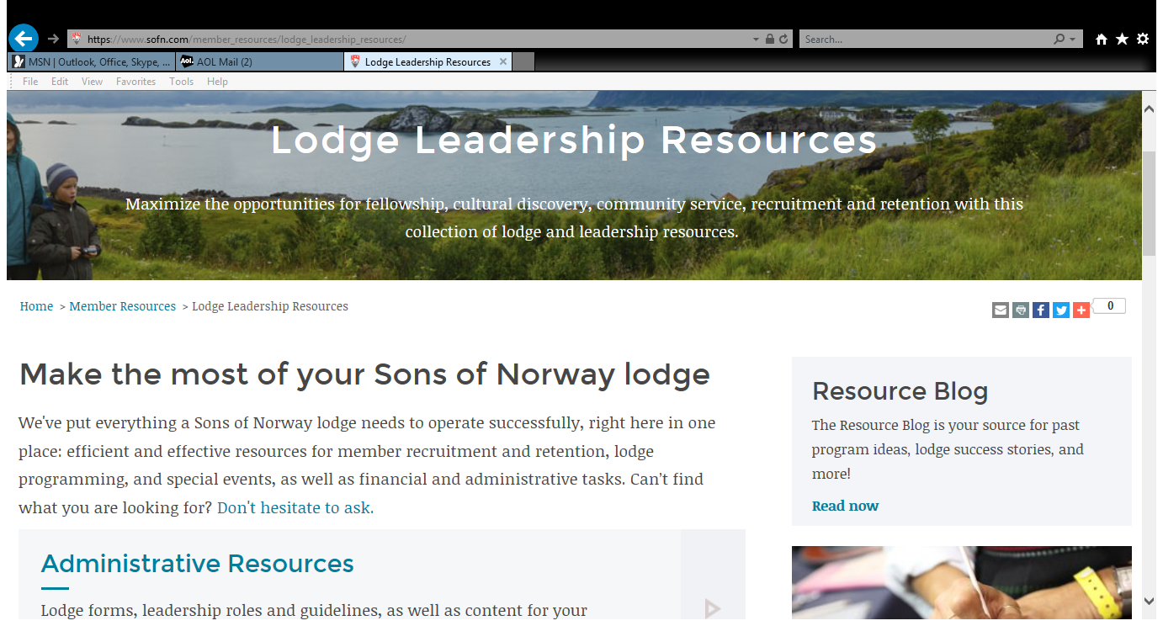

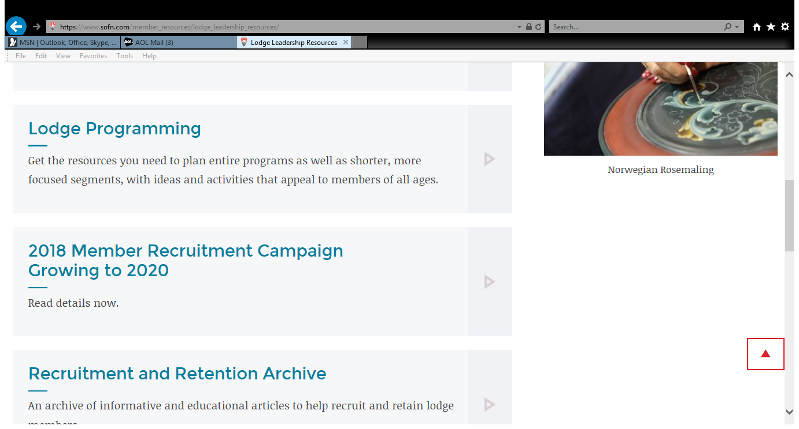

Fraternals Give

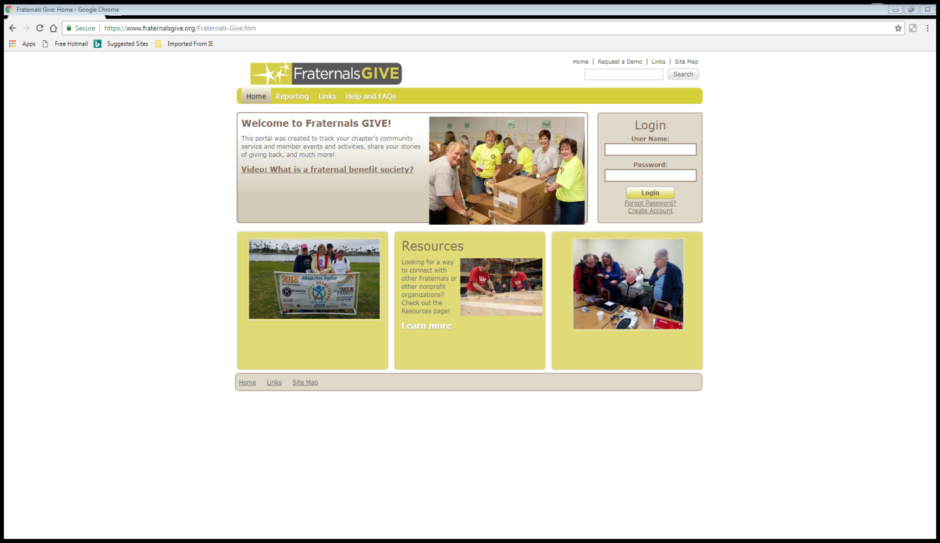
Sign in page User name is lodge name and number
Password is Password1
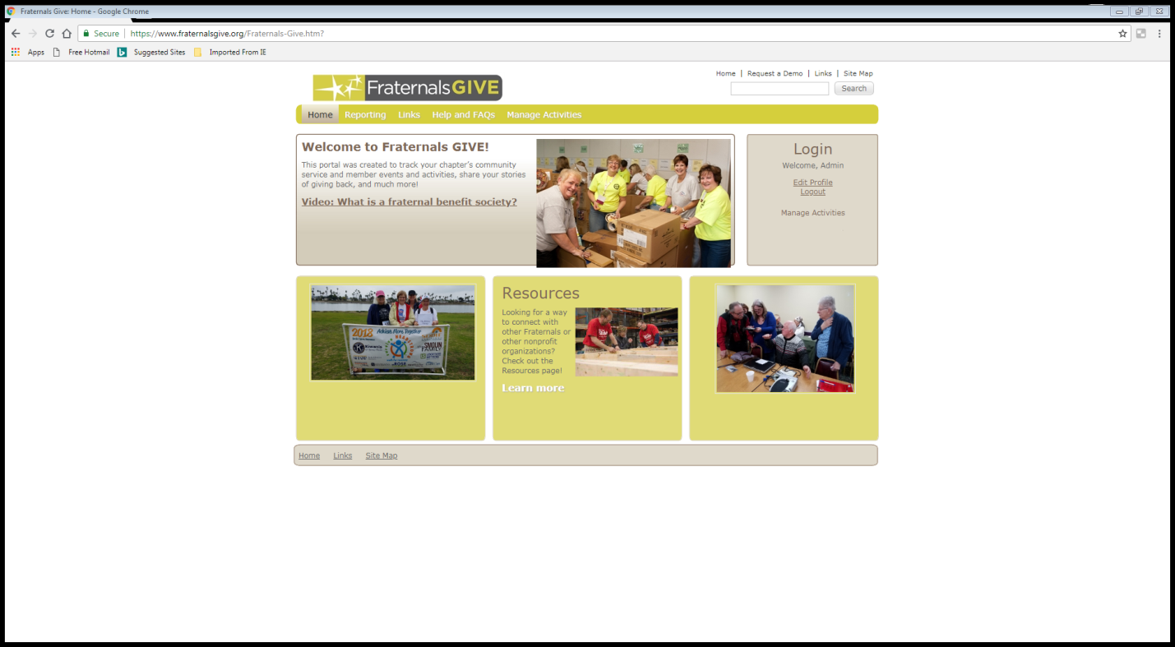

Next go to manage activities

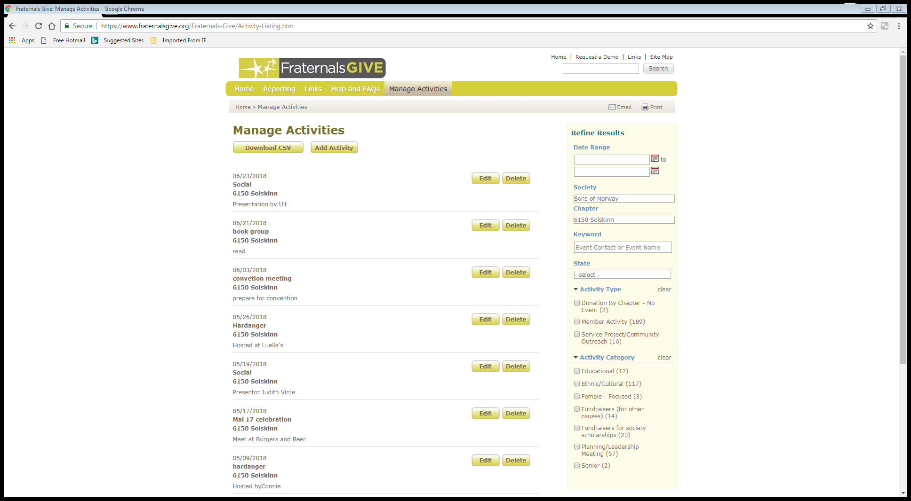
List of all activities logged.
On the right you can use the side bar to find the number of volunteer hours. If you use the Fraternal Gives Website you will not need to file that portion of the LAF.

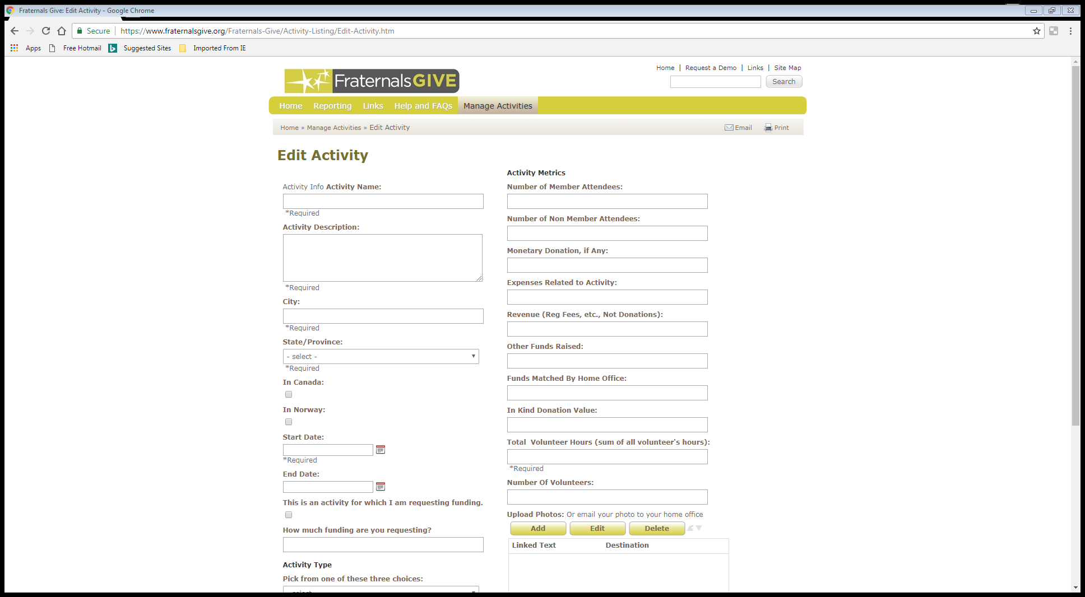
Put in hours and event

Deadlines
February 15, 2019 Lodge D17 financial forms
Lodge Achievement Form (LAF)
Family Lodge of the Year Form (FLOY)
American Fraternal Alliance Year End Report (AFA Year End Form)

May 15, 2019 IRS Form 990 filings
D17 & 990 for lodge and district building associations

District Six Resources

District Six Web Resources

Websites

Main District Six Website - https://sofn6.org
Main website for District Six announcements, events, and resources

Menu:
Home
Important Announcements
About Us
Board officers and contact information
Join Sons of Norway on-line
Zones/Lodges
List of area of each Zone
One page for each Zone with name of Zone Director and contact information. Map of all lodges in the Zone and link to website/Facebook for lodges in the Zone.

Events/News
District Six, Cultural, and Camp Norge newsletters
Major recurring events, Kretsstevner, Barneløpet, Rosemaling Seminars

Camp Norge
Link to the Camp Norge website

Youth
Links to youth-centric events, Camp Trollfjell and Trollfjell Folkehøgskule, Barneløpet
District Six Scholarships and Camperships

SMSC—Social Media Support Committee
On-line help request form
Tool kit -tutorials for creating Facebook pages and websites

Resources
Scandinavian Recipes
Cultural Skills program resources
Distribution Lists
Bylaws and Policy Book
Publicity Resources

Links – links to Headquarters, District, and general Norwegian websites/Facebook

Contact Us – On-line form for questions/comments to the District Six Board

2018 Convention Website - https://2018.sofn6.org
Information and photos from the 2018 District Six Convention

2020 Convention Website - https://2020.sofn6.org
Information about the upcoming 2020 District Six Convention, dates, location, programs, on-line registration…

Camp Norge Website - https://www.campnorge.org
Information about Camp Norge

Language and Heritage Programs Website - https://sofn6.org/arv
Information about past and future Camp Trollfjell and Trollfjell Folkehøgskule programs. On-line registration for campers and students. On-line applications for staff and Counselors in Training

Facebook

District Six Facebook Group - https://www.facebook.com/groups/377019032437840/
This Facebook Group is for all members of District Six to share information of general interest to all members. Common postings include announcements of District Six and Lodge events, Lodge newsletters, stories about all things Nordic.

Camp Norge Facebook Page - https://www.facebook.com/campnorgeofficial
Information about and photos of Camp Norge and official announcements from the Recreation Center Board.

Camp Norge Facebook Group - https://www.facebook.com/groups/429161770604252/
This Facebook Group is for all friends of Camp Norge to share their experiences and photos related to Camp Norge

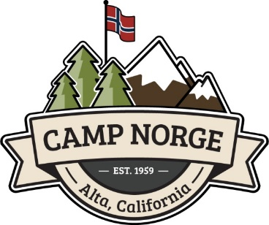
Camp Norge
Sons of Norway, District Six Recreation Center
PO Box 622, Alta CA 95701
503-389-2503 campnorge@yahoo.com, www.campnorge.org

The grounds consist of 46 acres of land with camping in a spectacular, natural meadow. There are 20 RV sites, complete with natural spring water and electrical hookups, and many areas to pitch a tent. If you like a little more amenity you can stay in the Historic Main House that was built in the 1930’s and provides our members with mountain charm and character. Included on the property are three rustic dormitories and a “Social Hall” complete with a full kitchen and fabulous views of the meadow. Members built the new state of the art Heritage Hall. This Hall is complete with full kitchen and room for 100 members and their guests to be used for a variety of events.

There is a Main house with 3 rooms for members only, Dorm #1-6 rooms, Dorm #2-4 rooms, Stabbur-1 room, Barn-1 room, 2 Cozy Cabins—1 room each
RV sites and tent camping

Camp Norge is for members and their guests, only. Reservations and deposits are required. You must bring your own bedding, pillows, towels, etc. You will be asked to show your Sons of Norway membership card. The facility is available for member sponsored family events and reunions, church groups, and club groups. Call for details and availability. Rates were effective November 7, 2017 and are subject to change. Room rates are calculated per person.

Cleaning and Damage Fees
All facilities are to be left as clean as when you arrived. If facilities are not left clean, a cleaning fee will be assessed of up to $250.00 for common areas and/or $10.00 per room.

Main House (3 rooms, for members only), Dorm #1- 6 rooms, Dorm #2 – 4 rooms,
Stabbur – 1 room, Barn – 1 room, 2 Cozy Cabins – 1 room each
Member: $15.00 plus 8% tax per person per night.
Heritage member: No charge if in the same room as parent.
Guest: $25.00 plus 8% tax per guest per night.
Guest, 15 and under: $7.00 plus 8% tax, in same room with parent.

RV Sites (water and electricity only – standard and 30 amp)
Member: $25.00 per RV per night.
Guest: $35.00 per RV per night.

Tent Camping
Member: $15.00 per tent per night.
Guest: $20.00 per tent per night.

Day Rate
$5.00 per person per day - for picnics, swimming, or visiting campers.

Pets
$2.00 per day per pet. Pets are only allowed to stay in the Cozy cabins and Dorm 2. They are not allowed in the other buildings, pool area, or rooms at any time. Owners are expected to clean up after their pets at all times and locations.

Century Club Sons of Norway
Goal is to work with the Sixth District Recreation Center Board as a fund raising group with the mission of raising funds for the maintenance of Camp Norge. Website to be developed.

Youth
Language Heritage Camp—Camp Trollfjell & Trollfjell Folkenhøgskule
District Six sponsors two camps for our youth. These camps promote the culture and heritage of Norway along with providing lots of fun and outdoor activities.
Camp Trollfjell 8-13 year olds
Trollfjell Folkhøgskule 14-17 year old
Camp Director Rebekah Strand

Scholarships and Camperships

District Six offers two ½ camperships to each camp. The guidelines are on the District Six website.
District offers up to three academic scholarships and one scholarship to Skogfjorden Norwegian language camp. Guidelines are on the District Six website.

My Lodge--Characteristics of Successful Lodges
Mission Oriented—Sons of Norway Sets and Achieves Goals
Strong Leadership Dynamic Programs and Social/Cultural Events
Recruits New Members and Retains Members Always a Positive Attitude
Provides a Value Added Experience Have Fun!

MAKE A YEAR’S PROGRAM CALENDAR

1 Have a committee collect ideas for the next year programs/socials starting in September or, if your lodge works on a seasonal calendar, in June.
2. Develop an interest questionnaire. Ask about what they would like to hear about. Think about meals or food offerings that support the program.
3. Next ask the Leadership Committee about more ideas and start putting dates and programs in order.
4. Confirm Speakers availability for the programs months in advance.
5. It is a good practice to write information about the program to confirm it in a letter with a copy to the presenter to sign and return. Include: date of program, time of arrival, title of program with a short synopsis that can be used for publicity, agreed upon honorarium, agreed upon mileage payment, and overnight lodging in member home or motel if necessary. What equipment is needed? Projector, screen, DVD player etc.
5. When program planning is completed, publish a year’s calendar so that members have a copy they may refer to when making plans. Some lodges have an annual directory that includes the events calendar.

Interest Survey--Please help us plan for
Fall 2019- Spring 2020

Types of meals
Circle all that you are interested in:
Brunch Lunch Dinner

Food
Circle all that you are interested in:

Pot luck Lutefisk Salmon dinner Shrimp Dinner

Traditional Norwegian foods & desserts

Soup & Salad Dinner Potato & Salad Dinner

Bar-b-que Spaghetti dinner

International Themes

Viking dinner Christmas pork ribbe dinner

Christmas meal: fill in entrée ___________________

Norwegian beer and Cheese tasting

Picnic

Events/Culture Programs
Circle the types of programs you are interested in:
Music: Entertainer Lodge Singing

Movies: Fiction History

Traditional crafts: Rosemaling Hardanger Wood carving

History: Norway today WWII Viking

Art Literature

Interactive activities: Crafts Runes Cultural Skills

Story telling Food Demonstrations Cooking classes

Your recommendations for programs or meals:

TRADITION

In this world of change it is nice to maintain some tradition. Sons of Norway has long ceremonial traditions, much of which has been changed with the times. Some traditions help with consistency and are just good communication and public relations and education traditions. Sons of Norway is way less formal today than it was in the past, and some lodges are more formal than others. Although protocol and decorum may sound a bit formal, outdated, and perhaps even archaic - etiquette and good manners will never go out of style.

Flags - All three flags should be displayed at each meeting.
All three National Anthems should be played and sung at the opening of a meeting.
The Norwegian Table Prayer is a nice tradition and it is a learning experience, learning to sing/say the prayer in Norwegian.
Introduction of Dignitaries: Often there are representatives from the International or District Boards. These visitors should be introduced so members can identify them and have an opportunity to interact. Ask if the District or International representative would like to speak at the meeting.
Guests should also be introduced so everyone knows there are guests present, and so that people make the guests feel welcome. If welcomed warmly, perhaps these guests will become members.
Recognition - always thank and recognize members who prepare the meal, set up, clean-up, and volunteer to present a program. Also, send them a hand written thank-you note, if possible. Appreciation goes a long way to assure continued lodge support.
Programming should be Norwegian, Scandinavian, or Norwegian-American from here in the US. If you have an Easter Program - tie it to the heritage or culture of Norway/Scandinavia.

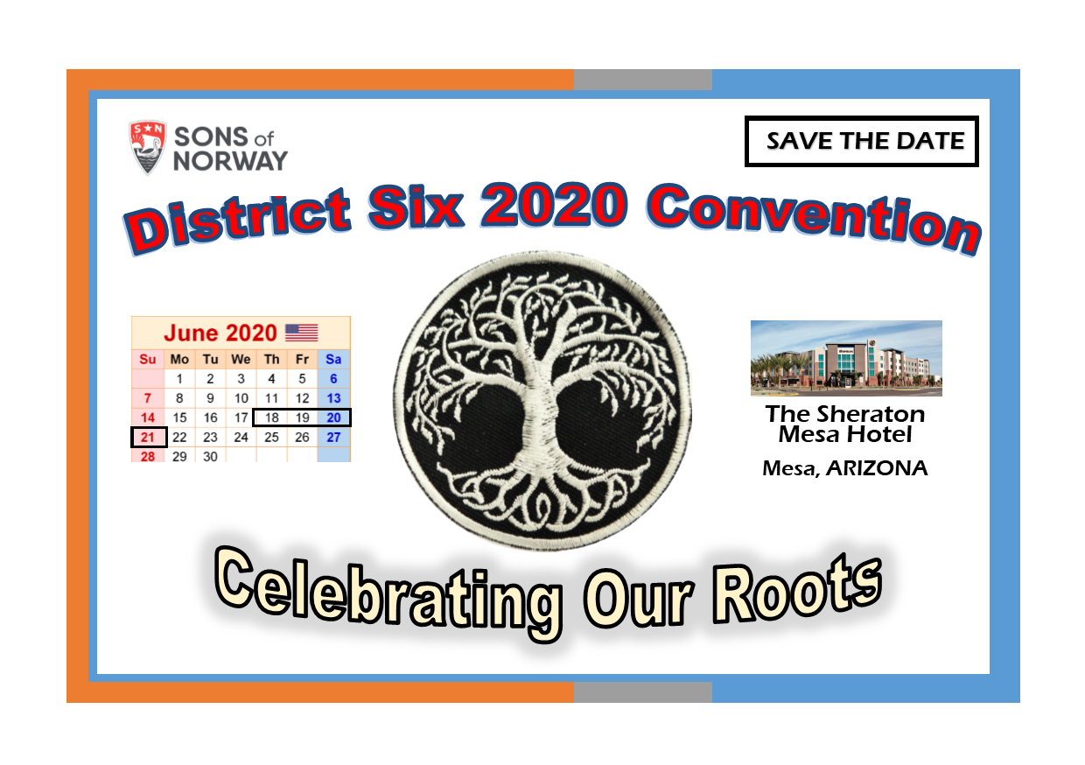

Lodge Fundraising Suggestions
Many Lodges charge a nominal fee for meals, others charge much more. The fees for regular meals vary from $5.00 to $20. Special events are more. Many will charge a lower fee for advanced reservations, so food can be properly planned. Also, a higher fee for non-members is sometimes charged as an incentive for joining. Also some lodges charge for beverages other than water and coffee. Others, due to the nature of their lodge meeting place or Bylaws, ask for donations for beverages. Also beer and wine are a good way to make extra money, but that is based on your location.
50/50 drawings are an easy fundraiser. Just sell tickets, and whoever‘s ticket is drawn wins half the amount. A drawing theme basket may be awarded with tickets sold for 1 ticket for $1, or 6 tickets for $5. Silent auctions are good fundraisers.
Selling lefse and/or Norwegian baked goods is a good fundraiser. People call lodges asking where they can purchase lefse or kranskake. Four pieces of lefse can go for $5-$7. Cookies, at heritage days or bake sales, go for $1 for 3 cookies on a plate, almond cakes can be sold for $10. Krumkake, sandbakkles, and breads are also favorites at bake sales.
Sons of Norway Resources
Program ideas for earning extra money for your lodge, scholarship funds and more:
#13 Viking On A Stick Fundraiser (Revised 10/2010) - selling batter dipped meatballs
#38 Norskies - selling fried dough with cinnamon
#56 Hand-Knit Cap and Scarf - selling hand-knitted items
Brainstorming ideas….what ideas do you have to share?

How to Submit a Photo
For Viking Magazine

Select a digital (or professional processed*) photo with:
- The highest resolution possible (300 dpi – dots per inch – or greater)
- Sons of Norway members as the subject matter
- Visual interest, crisp and clear images, and good lighting
- No editing
Save it to your computer, “save as” a jpeg file; name it with the name of your Lodge and the date.

Complete a submission form:
Download a blank “Fill-in and sign” Submission Form into your Document file. Save it with this name, BLANKVMSF. (It is a “fill-in and sign” document, so you can just put your cursor on a black line and start typing in your information, right on your computer). Then whenever you want to submit a photo:
- Open the Blank-VMSF. (It is a “fill-in and sign” document, so you can just put your cursor on a blank line and start typing in your information, right on your computer).
- Complete every item on the form—use as much detail as possible –then “save as” with the same name as the photo jpeg file (name of your lodge and ate).

Attach both the saved completed form AND the saved jpeg photo file to an email and send to your District PRO.

*A professional processed photo must be:
- A minimum physical size of 3” x 5” image on professionally processed photo paper
- Flawless, unaltered in any way, with no writing on the reverse side
- Mailed, first class, in a flat mailer, along with competed submission form, to the District Six PRO.

SON-DISTRICT SIX-kw-July 2018

See attached
Viking submission form and
how to District Photo Submission Guide

